**Texas Tech University**

**Department of Computer Science**

**Course:** Introduction to Artificial Intelligence **Group:** 1

**Student:** Felipe Chavarria Fernandez **Email:** fchavarriafernandez@gmail.com

**Date:** Friday, June 28, 2019

Table of Contents

Week 6 - Homework 6 1

Practice 1 1

Optional Problem 1b 1

Practice 2 1

Practice 3 1

Optional Problem 3b 1

# Week 6 - Homework 6

## Practice 1

We start creating the lists to store the metrics for accuracy and cost for train and test data like so:

# Initialize lists

cost_against_training_data = []

cost_against_test_data = []

accuracy_against_training_data = []

accuracy_against_test_data = []

then in each evaluation step inside the while loops we store each of the metrics we compute:

# Save the metrics to the history

cost_against_training_data.append(trn_cost_avg)

cost_against_test_data.append(test_cost)

accuracy_against_training_data.append(train_accuracy)

accuracy_against_test_data.append(test_accuracy)

then we print the final results:

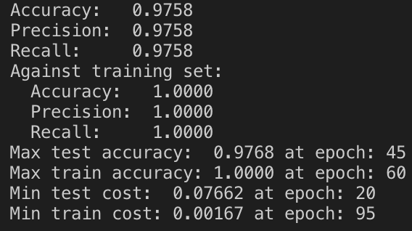

And plot Cost vs. epoch (both training and test) and Accuracy vs. epoch (both training and test):





## Optional Problem 1b

## Practice 2

## Practice 3

## Optional Problem 3b